Initial Project Planning Report

|  |  |
| --- | --- |
| Date | 28-09-2024 |
| Team ID | LTVIP2024TMID24947 |
| Project Name | SmartLender - Applicant Credibility Prediction for Loan Approval |
| Maximum Marks | 4 Marks |

**Product Backlog, Sprint Schedule, and Estimation**

Use the below template to create a product backlog and sprint schedule

|  |  |  |  |  |  |  |  |
| --- | --- | --- | --- | --- | --- | --- | --- |
| **TASKS** | **Functional**  **Requirement (Epic)** | **User Story**  **Number/**  **Task no** | **User Story / Task** | **Priority** | **Team**  **Members** | **Task Start Date** | **Task End Date (Planned)** |
| Task-1 | Data Collection | TSk-275328 | Download the dataset | Low | nivas | 2024/09/20 | 2024/09/22 |
| Task-2 | Visualization and analyzing the data | TSK-275329 | Importing the libraries | Low | nivas | 2024/09/20 | 2024/09/22 |
| Task-2 | Visualization and analyzing the data | TSK-275330 | Read the dataset | Medium | nivas | 2024/09/24 | 2024/09/29 |
| Task-2 | Visualization and analyzing the data | TSK-275331 | Univariant analysis | Medium | surya | 2024/09/24 | 2024/09/29 |
| Task-2 | Visualization and analyzing the data | TSK-275332 | Bi variant analysis | Medium | surya | 2024/09/24 | 2024/09/29 |
| Task-2 | Visualization and analyzing the data | TSK-275333 | Multi variant analysis | Medium | surya | 2024/09/24 | 2024/09/29 |

|  |  |  |  |  |  |  |  |
| --- | --- | --- | --- | --- | --- | --- | --- |
| **Sprint** | **Functional**  **Requirement (Epic)** | **User Story**  **Number** | **User Story / Task** | **Priority** | **Team**  **Members** | **Task Start Date** | **Task End Date (Planned)** |
| Task-2 | Visualization and analyzing the data | TSK-275334 | Descriptive analysis | Low | venkatesh | 2024/09/29 | 2024/10/01 |
| Task-3 | Data Pre -Processing | TSK-275335 | Check null values | High | nivas | 2024/09/29 | 2024/10/02 |
| Task-3 | Data Pre-Processing | TSK-275336 | Handling Categorial Values | High | venkatesh | 2024/10/01 | 2024/10/03 |
| Task-3 | Data Pre -Processing | TSK-275337 | Balancing the data | High | nivas | 2024/10/02 | 2024/10/04 |
| Task-3 | Data Pre -Processing | TSK-275338 | Scaling the data | Medium | naik | 2024/10/03 | 2024/10/05 |
| Task-3 | Data Pre -Processing | TSK-275339 | Splitting Data into Train and Test | Medium | surya | 2024/10/04 | 2024/10/05 |
| Task-4 | Model Building | TSK-275340 | Decision tree model | High | surya | 2024/10/05 | 2024/10/07 |
| Task-4 | Model Building | TSK-275341 | Random forest model | High | nivas | 2024/10/06 | 2024/10/07 |
| Task-4 | Model Building | TSK-275342 | KNN model | High | naik | 2024/10/07 | 2024/10/08 |
| Task-4 | Model Building | TSK-275343 | Xgboost Model | High | venkatesh | 2024/10/08 | 2024/10/08 |
| Task-4 | Model Building | TSK-275344 | Compare the model | low | surya | 2024/10/09 | 2024/10/08 |
| Task-4 | Model Building | TSK-275345 | Evaluating performance of the model and saving the model | low | surya | 2024/10/09 | 2024/10/08 |
| Task-5 | Application building | TSK-275346 | Building the html pages | high | nivas | 2024/10/09 | 2024/10/13 |
| Task-5 | Application building | TSK-275347 | Build python code | high | nivas | 2024/10/10 | 2024/10/15 |
| **Sprint** | **Functional**  **Requirement (Epic)** | **User Story**  **Number** | **User Story / Task** | **Priority** | **Team**  **Members** | **Task Start Date** | **Task End Date (Planned)** |
| Task-5 | Application building | TSK-275348 | Run the application | low | nivas | 2024/10/10 | 2024/10/15 |

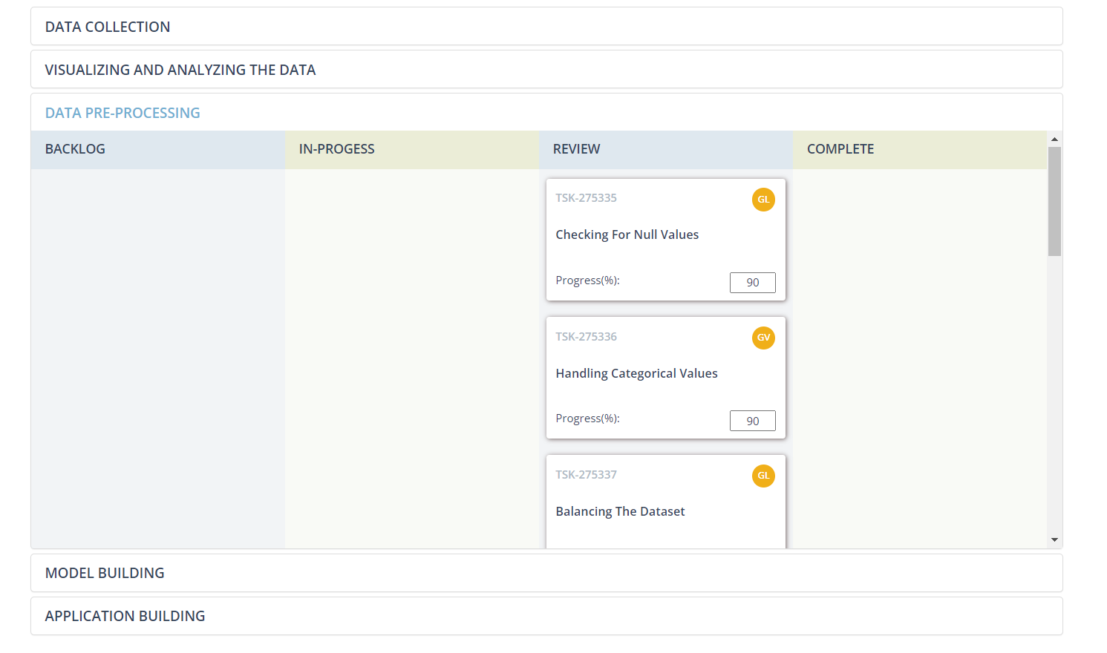**Screenshots:**

